
PRESS & MEDIA KIT
RICH PETRELLI
Author of The Templar’s Legacy Trilogy
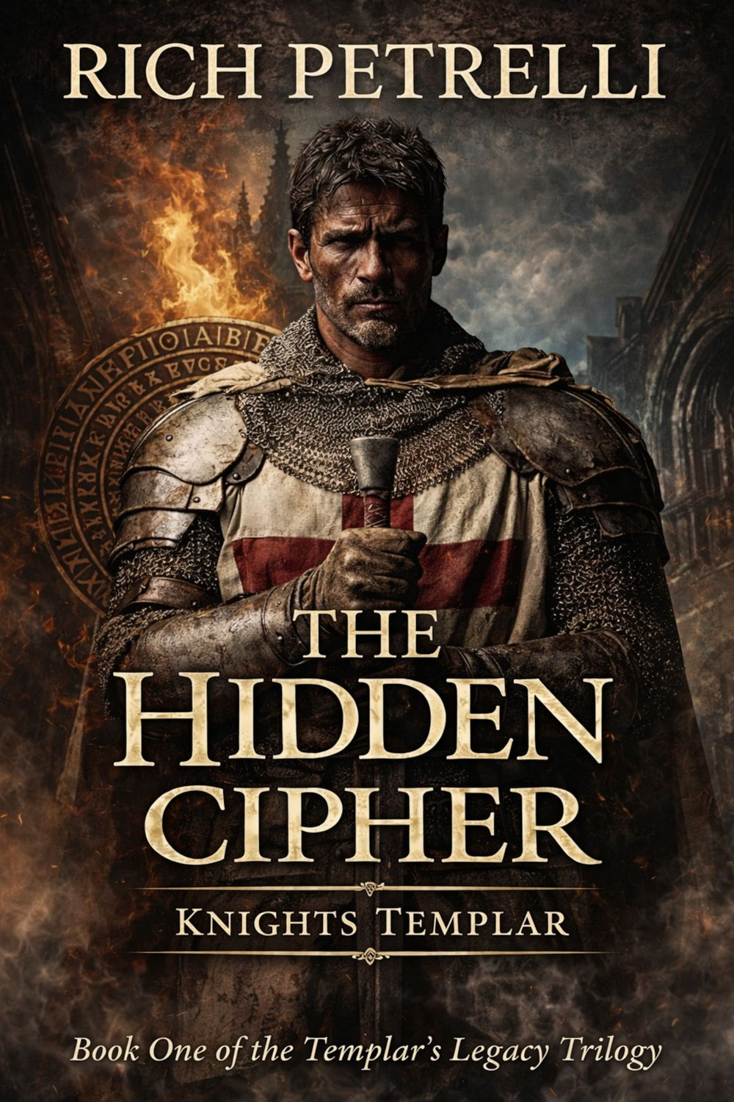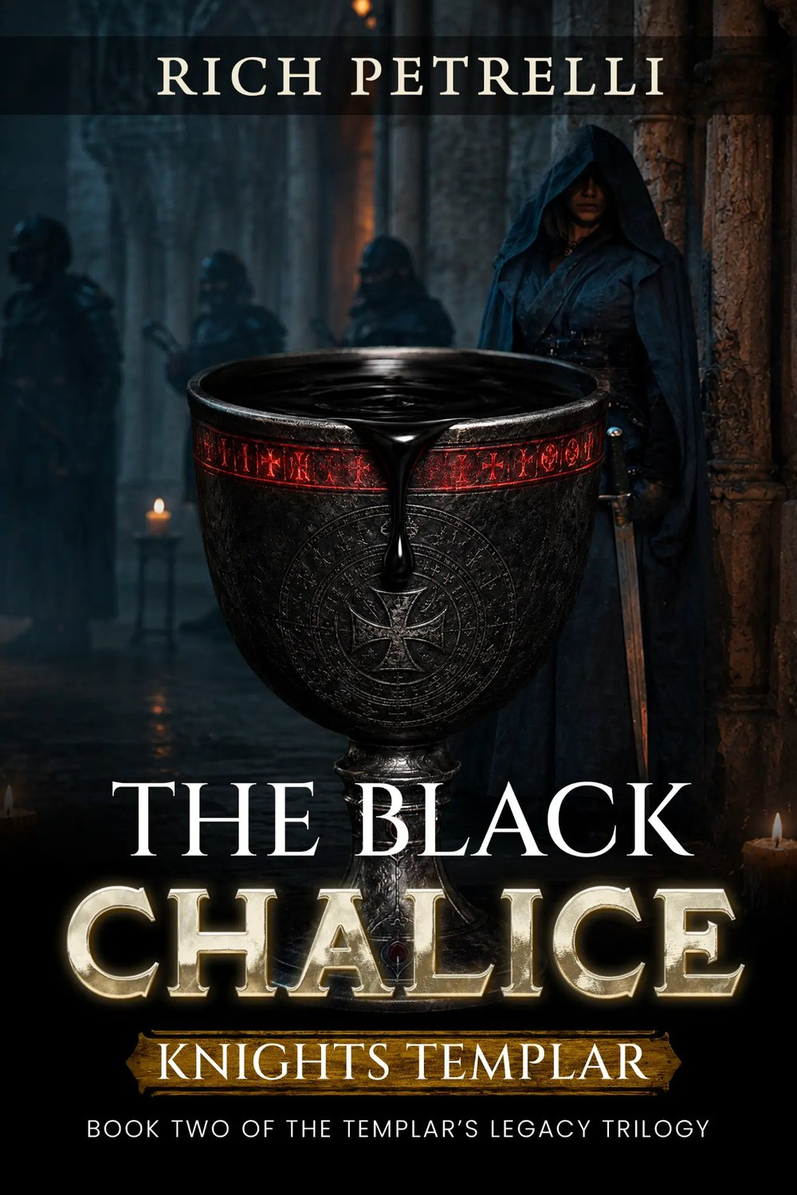
The Hidden Cipher · The Black Chalice · Babel
richpetrelli.com · press@richpetrelli.com

Welcome
Welcome to the Rich Petrelli press kit. Here you’ll find author information, book descriptions, photographs, and media assets for interviews, reviews, podcasts, articles, and other media features. Hi-res images are included in the accompanying ZIP file and at richpetrelli.com/press-kit.

At a Glance
Rich Petrelli is a Florida-based author of historical conspiracy thrillers. His Templar’s Legacy Trilogy—The Hidden Cipher, The Black Chalice, and Babel—follows cryptologist Dr. Elena Voss into a centuries-old Knights Templar conspiracy. He and his wife, Zona, have traveled full-time by RV for more than a decade.

Media Contact
MEDIA CONTACT | Rich Petrelli
EMAIL | press@richpetrelli.com
PHONE | (863) 701-4515
CONTACT FORM | richpetrelli.com/contact (choose “Press & Media”)

01 · ABOUT THE AUTHOR

Rich Petrelli


Short Bio (~50 words)
Rich Petrelli is a Florida-based author of historical conspiracy thrillers. His Templar’s Legacy Trilogy—The Hidden Cipher, The Black Chalice, and Babel—follows cryptologist Dr. Elena Voss into a centuries-old Knights Templar conspiracy. He and his wife, Zona, have traveled full-time by RV for more than a decade.

Medium Bio (~150 words)
Rich Petrelli is a Florida-based author whose novels blend ancient mysteries, global conspiracies, and fast-paced suspense. His debut thriller, The Hidden Cipher (Color & Quill, 2025), launched the Templar’s Legacy Trilogy, which follows cryptologist Dr. Elena Voss, DGSE operative Antoine Rousseau, and researcher Liam Hayes as they chase a secret the Knights Templar died protecting. The series continues with The Black Chalice (2026) and concludes with Babel (February 2027). Readers’ Favorite gave The Hidden Cipher a five-star review, calling it “an exhilarating ride.”
Rich’s fiction is shaped by his passion for history, science, and human behavior—and by life on the road. He and his wife, Zona, have traveled full-time by RV for more than a decade, and the historic cities and remote landscapes they encounter often inspire the settings of his stories. Beyond thrillers, he has written nonfiction, including ISOMETONICS, and children’s books such as The Adventures of Pman & Pookie and Wiggle & Giggle.

Long Bio (~300 words)
Rich Petrelli is a Florida-based author of fiction and nonfiction, best known for thrillers that plunge readers into worlds where ancient mysteries, hidden orders, and cutting-edge science collide. Born in Bethpage, New York, he now lives a nomadic life: for more than a decade, he and his wife, Zona, have traveled full-time by RV, a journey that has carried them across diverse landscapes and cultures and that infuses his fiction with authentic settings and a deep appreciation for the mysteries history holds.
His debut thriller, The Hidden Cipher (Color & Quill, December 2025), opens the Templar’s Legacy Trilogy. When a forbidden Templar manuscript resurfaces after seven centuries, cryptologist Dr. Elena Voss is drawn into a conspiracy guarded by silence and blood. Readers’ Favorite awarded the novel a five-star review, praising its complex plot, action-packed suspense, and “exceptionally accomplished” characterization. The saga escalates in The Black Chalice (August 2026), as a deadly pathogen sweeps the globe, and concludes in Babel: Every Vow Must Be Tested, arriving February 14, 2027.
Rich designed the trilogy as an escalation. Book One deliberately “starts with absence”—the Templars appear only as fragments and echoes—so that each installment reveals more of the Order and raises the stakes. At its center is a heroine who is not an action hero by choice: Elena is analytical and careful, a scholar forced to live with uncertainty when her expertise leads her deeper into danger.
The series reflects years of research into cryptology, genetics, and faith, and the same curiosity drives his work in other genres: the fitness guide ISOMETONICS: The Intermittent Fasting Fitness Plan; the social commentary Words Are Words, Violence Is Violence; RV-travel guides; and children’s books including The Adventures of Pman & Pookie and Wiggle & Giggle. When he isn’t writing, Rich enjoys studying history, science, and human behavior, and practicing martial arts.

Alternate headshot.

02 · SERIES OVERVIEW

The Templar’s Legacy Trilogy
A sweeping saga of cryptology, genetics, and faith. Three books. One buried truth.
Three novels. One conspiracy spanning centuries. Follow cryptologist Dr. Elena Voss from the first recovered cipher to a final reckoning that reaches across centuries. Each installment deepens the conspiracy while carrying the same blend of hidden history, coded clues, and relentless suspense—drawing on real Templar legends and authentic European locations as the backdrop for an entirely imagined story.
BOOK 1 OF 3  The Hidden Cipher  A relentless chase through ancient secrets, modern power, and the shadows between. | BOOK 2 OF 3  The Black Chalice  The battle has reached New York City. | BOOK 3 OF 3  Babel  History was never the enemy. Humanity was.

Reading Order & Release Dates
BOOK 1 | The Hidden Cipher — December 5, 2025
BOOK 2 | The Black Chalice — August 19, 2026
BOOK 3 | Babel: Every Vow Must Be Tested — February 14, 2027 (Kindle eBook preorder)

Meet the Characters
Official character portraits from richpetrelli.com/meet-the-characters.
  Dr. Elena Voss  CRYPTOLOGIST  At the center of the trilogy, Elena sees patterns where others see fragments—a gift that draws her into a conspiracy reaching from the Knights Templar to a modern threat. | 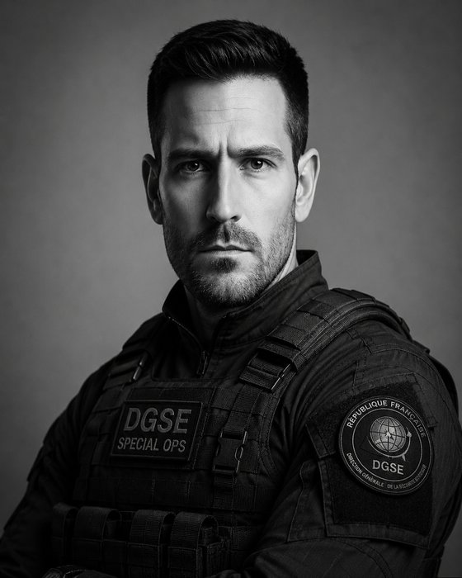  Antoine Rousseau  DGSE BLACK OPS  A seasoned DGSE operative whose intelligence, combat skills, and instinct for danger protect the team; his past and loyalties are more complicated than they first appear. |   Liam Hayes  ANALYST / RESEARCHER  Elena’s closest ally, with a talent for connecting pieces that others overlook.
  Sarah Mills  MI5 COMMANDER  Brings discipline and a willingness to make difficult decisions as the threat moves beyond borders. |   Gideon Valmont  PRECEPTOR OF THE WESTERN COMMANDERY  A wealthy philanthropist and collector whose polished persona hides a deeper connection to the modern Knights Templar. | 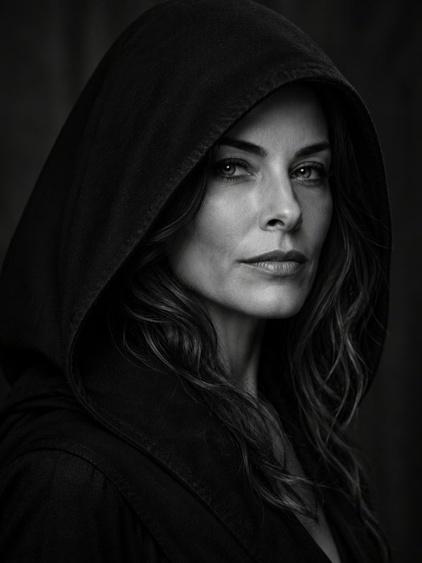  Isabella Guiomar  ARCHITECT OF THE GUILD  Leads the clandestine Guild of Shadows from behind the scenes—one of the trilogy’s most dangerous adversaries.
  Konstantin Volkov  GUILD BIOWEAPONS SCIENTIST  A brilliant, unrestrained scientist devoted to biological weapons capable of changing history. |   Dr. Sarah Chen  DIRECTOR OF THE WHO  Leads the international medical response to a threat spreading faster than medicine can contain. | 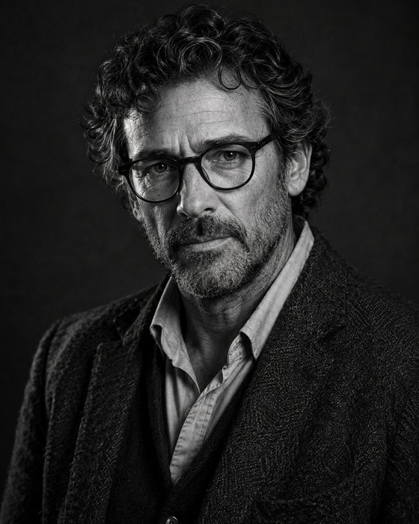  Dr. Henrique Tavares  ANTIQUITIES COLLECTOR  A scholarly collector of rare artifacts whose knowledge makes him an intriguing figure in the conspiracy.

03 · BOOK 1 OF 3 · THE TEMPLAR’S LEGACY TRILOGY

The Hidden Cipher
A Knights Templar Conspiracy Thriller
A relentless chase through ancient secrets, modern power, and the shadows between.
SERIES | The Templar’s Legacy Trilogy, Book 1
GENRE | Historical thriller / Knights Templar conspiracy thriller
PUBLISHER | Color & Quill
RELEASE DATE | December 5, 2025
FORMATS | Paperback · Hardcover · Kindle & eBook · Audiobook
ISBN (PAPERBACK) | 979-8-218-94274-8
ISBN (HARDCOVER) | 979-8-218-94275-5
ISBN (EBOOK) | 979-8-232-44747-2
KINDLE ASIN | B0G2TLK8WS
PAGE COUNT | 405 (paperback)
TRIM SIZE | 6 × 9 in (paperback)
LIST PRICE | $15.99 (paperback)

Short Synopsis
When a forbidden Templar codex resurfaces after seven centuries, cryptologist Dr. Elena Voss recognizes symbols tied to secrets buried deep within the Vatican. Joined by Antoine Rousseau and Liam Hayes, she follows a trail through Europe’s cathedrals, crypts, and ancient ruins while a powerful network races to silence the truth. But each discovery draws them closer to a secret the Knights Templar died protecting—and to a conspiracy that was never meant to be uncovered.

Long Synopsis
Drawing on real Templar legends, authentic European locations, and centuries-old mysteries, The Hidden Cipher weaves documented history into a high-stakes modern thriller.
When a forbidden Templar manuscript resurfaces after seven centuries, cryptologist Dr. Elena Voss is the first to recognize the symbols etched inside—and the deadly warning buried beneath them. What begins as a routine analysis pulls her into a conspiracy protected by silence, blood, and a hidden order determined to reclaim the cipher at any cost.
Joined by covert operative Antoine Rousseau and researcher Liam Hayes, Elena follows a hidden lattice of encrypted symbols across Europe—through echoing cathedrals, forgotten monasteries, restricted archives, and the sealed chambers of Templar strongholds. Each revelation pulls them deeper into a silent war that has smoldered for centuries… and every step forward stirs enemies who have killed to keep this truth buried.
Because the cipher doesn’t just rewrite history—it reveals a truth powerful enough to end the human race.
Perfect for fans of Dan Brown, Steve Berry, James Rollins, Simon Toyne, and Raymond Khoury.

Praise
“This is a book that fans of Dan Brown will adore… Rich Petrelli’s novel is an exhilarating ride, and I can’t wait to read the entire trilogy.”
— Ruffina Oserio, Readers’ Favorite (five-star review, Dec. 11, 2025)
“The plot is complex and filled with action-packed scenes and suspense… This book gets my vote on every level.”
— Ruffina Oserio, Readers’ Favorite

Where to Buy
- Amazon (Kindle): https://www.amazon.com/dp/B0G2TLK8WS
- Amazon (paperback): https://www.amazon.com/dp/B0G4DV366P
- Audible: https://www.audible.com/pd/The-Hidden-Cipher-Audiobook/B0H666CMH9
- Apple Books: https://books.apple.com/us/book/knights-templar-the-hidden-cipher-a-conspiracy-thriller/id6755897114
- Barnes & Noble: https://www.barnesandnoble.com/w/x/x?ean=2940183287066
- Google Play: https://play.google.com/store/books/details?id=IL6cEQAAQBAJ
- Kobo: https://www.kobo.com/search?query=9798232447472
- Smashwords: https://www.smashwords.com/books/view/1913019
- Signed editions: https://thehiddenchalice.com/order-your-signed-edition-of-the-hidden-cipher
- Goodreads: https://www.goodreads.com/book/show/244135364-the-hidden-cipher
Book page: https://richpetrelli.com/book/the-hidden-cipher/

04 · BOOK 2 OF 3 · THE TEMPLAR’S LEGACY TRILOGY

The Black Chalice
A Knights Templar Conspiracy Thriller
The battle has reached New York City.
SERIES | The Templar’s Legacy Trilogy, Book 2
GENRE | Historical thriller / Knights Templar conspiracy thriller
PUBLISHER | Color & Quill
RELEASE DATE | August 19, 2026
FORMATS | Paperback · Hardcover · Kindle eBook
ISBN (PAPERBACK) | 9798234155702
ISBN (HARDCOVER) | 979-8-234-15571-9
KINDLE ASIN | B0H64N1FTY
PAGE COUNT | 216
LIST PRICE | $15.99 (paperback)

Short Synopsis
The search that began in The Hidden Cipher becomes a fight for survival when a deadly pathogen begins sweeping across the globe. Elena Voss and her allies race across continents to stop a conspiracy centuries in the making, following a trail that reaches from ancient secrets to a terrifying modern threat. But as the death toll rises, they uncover an even darker truth: the artifact they pursued may hold the blueprint for humanity’s extinction—and time is running out.

Long Synopsis
As a deadly new plague spreads across the globe, cryptologist Elena Voss races to uncover the truth behind an ancient conspiracy that has survived for centuries. But this time, her enemies are prepared, their plans are already in motion, and every victory comes at a devastating cost.
When a mysterious guardian from the present-day Knights Templar steps from the shadows, Elena must decide who she can trust before history’s darkest secret reshapes the future of humanity.
The plague survived. So did the Order sworn to stop it.
From hidden archives and encrypted manuscripts to forgotten relics and centuries-old secrets, every discovery pulls Elena and Liam deeper into a conspiracy that has quietly shaped history for generations. As the line between ally and enemy vanishes, they uncover evidence that the legendary Knights Templar may still exist—hidden in plain sight, protecting humanity from a threat the world has never known.
But an unseen enemy is already moving. Ancient knowledge has become a modern weapon, and every clue brings the next catastrophe closer. In a relentless race spanning continents, every decision could save millions… or doom them.
Perfect for fans of Dan Brown, Steve Berry, Raymond Khoury, and James Rollins.

Praise
“Rich Petrelli's The Black Chalice explodes from the very first page. … The Black Chalice is intricately plotted, propulsive, and twisty, following a trail that leads to a seven-hundred-year-old secret beneath Antioch. The characters are stunningly created. Elena is not just brilliant; she is stubborn, and her sixty-second rule for grief, the seconds in which she has to absorb and feel whatever she has to feel, becomes an extension of her personality. Despite the nonstop action, the heroes enjoy the banter. The plot is stocked with surprises, and you have no clue where it will take you. Rich Petrelli's prose is exquisite, with clipped sentences, a chillingly clinical villain POV, and encrypted texts woven into the story. This smart, cinematic novel is surprisingly moving; it does not just build huge stakes; it weaponizes the sky.”
— Ruffina Oserio, Readers’ Favorite (5 stars)
“grabs you from the first outbreak and doesn't let go.”
— LubyH23, ARC review

Where to Buy
- Amazon: https://www.amazon.com/dp/B0HFR2H6G2
- Amazon (Kindle): https://www.amazon.com/dp/B0H64N1FTY
- Ebook (all stores): https://books2read.com/u/mlDdMq
Book page: https://richpetrelli.com/book/black-chalice/

05 · BOOK 3 OF 3 · THE TEMPLAR’S LEGACY TRILOGY

Babel
Every Vow Must Be Tested
History was never the enemy. Humanity was.
SERIES | The Templar’s Legacy Trilogy, Book 3 (conclusion)
GENRE | Historical thriller / Knights Templar conspiracy thriller
PUBLISHER | Color & Quill
RELEASE DATE | February 14, 2027 (Kindle eBook preorder available)
FORMATS | Kindle eBook (preorder) · Paperback (coming soon)
KINDLE ASIN | B0HDYFLMHR
PAGE COUNT | approx. 220 pages
LIST PRICE | $15.99 (paperback, coming soon)

Short Synopsis
Every clue has led to the conspiracy’s endgame. As civilization teeters on the edge of collapse, Elena Voss, her allies, and the modern Knights Templar race against time to stop an enemy that has spent decades preparing the world for a final reckoning. But the deeper they descend into the conspiracy, the more terrifying the truth becomes: Babel was never merely a legend. It was a warning—and now, the countdown has begun.

Long Synopsis
The search that began in The Hidden Cipher and intensified in The Black Chalice has led Elena Voss and her allies to a single, terrifying truth.
For centuries the Knights Templar guarded a secret so dangerous it was erased from history itself. Now someone intends to unleash it.
As civilization teeters on the edge of collapse, cryptologist Elena Voss, analyst Liam Hayes, DGSE Black Ops agent Antoine Rousseau, and the modern Knights Templar must confront an enemy who has spent decades preparing the world for a final reckoning.
Every clue has led here. Every sacrifice has been building toward this moment. The conspiracy is no longer hidden. The 72-hour countdown has begun.
Babel was never just a legend. It was a warning.
Perfect for fans of Dan Brown, Steve Berry, Raymond Khoury, and James Rollins.

Where to Buy
- Amazon Kindle (preorder): https://www.amazon.com/dp/B0HDYFLMHR
- Paperback coming soon.
Book page: https://richpetrelli.com/book/babel-every-vow-must-be-tested/

06 · PRAISE & REVIEWS

Praise for the Trilogy

★★★★★ Readers’ Favorite five-star reviews · The Hidden Cipher · The Black Chalice
THE HIDDEN CIPHER
“This is a book that fans of Dan Brown will adore… Rich Petrelli’s novel is an exhilarating ride, and I can’t wait to read the entire trilogy.”
— Ruffina Oserio, Readers’ Favorite (five-star review, Dec. 11, 2025)
THE HIDDEN CIPHER
“The plot is complex and filled with action-packed scenes and suspense… This book gets my vote on every level.”
— Ruffina Oserio, Readers’ Favorite
THE BLACK CHALICE
“Rich Petrelli's The Black Chalice explodes from the very first page. … The Black Chalice is intricately plotted, propulsive, and twisty, following a trail that leads to a seven-hundred-year-old secret beneath Antioch. The characters are stunningly created. Elena is not just brilliant; she is stubborn, and her sixty-second rule for grief, the seconds in which she has to absorb and feel whatever she has to feel, becomes an extension of her personality. Despite the nonstop action, the heroes enjoy the banter. The plot is stocked with surprises, and you have no clue where it will take you. Rich Petrelli's prose is exquisite, with clipped sentences, a chillingly clinical villain POV, and encrypted texts woven into the story. This smart, cinematic novel is surprisingly moving; it does not just build huge stakes; it weaponizes the sky.”
— Ruffina Oserio, Readers’ Favorite (5 stars)

What Readers Are Saying

The Hidden Cipher
“A gripping, fast-paced thriller that blends history, mystery, and action in all the right ways.”
— Tom Richards, Goodreads reader review (Dec. 8, 2025)
“Ancient secrets and modern danger collide in a way that’s hard to put down.”
— Ethan, Goodreads reader review (Jan. 29, 2026)
“Elena Voss is a strong, believable lead, and I liked how the code-breaking and history actually drive the plot instead of just decorating it.”
— Olivia Grant, Goodreads reader review (Feb. 6, 2026)
“The pacing is tight and addictive, with clues layered so cleverly that you find yourself examining every detail alongside the characters.”
— Matt Norton, reader review published on richpetrelli.com
“I could not put it down… Felt like a blend of Dan Brown and Raiders of the Lost Ark.”
— Ana Lisa, reader review published on richpetrelli.com

The Black Chalice
“The Black Chalice is one of those thrillers that grabs you from the first outbreak and doesn't let go. What I liked immediately is how grounded the opening feels — a deadly pathogen erupting in New York, panic spreading faster than the infection itself — and then, almost quietly, the story widens into something far older and far stranger. Dr. Elena Voss, analyst Liam Hayes, and former DGSE operative Antoine Rousseau make a compelling trio: sharp minds, different skill sets, and that shared sense of being pulled into something much bigger than any of them expected. The pacing has that relentless, globe‑spanning urgency that suits a conspiracy centuries in the making. Every new outbreak reveals another fragment of an impossible pattern, and the way those clues lead back to the Knights Templar gives the book a lovely archaeological‑mystery flavour. I enjoyed how the historical threads are woven into the modern danger — not as dusty lore, but as living secrets that still have teeth. The Black Chalice itself is a great hook. It's not just an artefact; it's a mystery that feels both sacred and terrifying, something buried not to hide power but to protect humanity from it. The idea that someone has spent decades preparing for this moment — believing civilization must be broken before it can be rebuilt — adds a chilling philosophical edge. It's not just villainy; it's ideology, and that makes the threat feel far more real. Elena is a strong anchor throughout. Her cryptologist's mind gives the story clarity, and her determination keeps it grounded even when the stakes become apocalyptic. Liam and Antoine round out the team beautifully — one analytical, one hardened by experience — and their dynamic adds warmth to a plot that could easily have felt cold. Instead, it feels human, urgent, and quietly hopeful.”
— LubyH23, ARC review
All quotes are verbatim excerpts from the cited sources (ellipses mark omissions).

07 · FAST FACTS

Fast Facts
AUTHOR | Rich Petrelli
BORN | Bethpage, New York
HOME BASE | Florida (Tampa area) — has traveled full-time by RV with his wife, Zona, for more than a decade
GENRE | Historical conspiracy thrillers; also nonfiction and children’s books
SERIES | The Templar’s Legacy Trilogy (3 books)
BOOK 1 | The Hidden Cipher — December 5, 2025
BOOK 2 | The Black Chalice — August 19, 2026
BOOK 3 | Babel: Every Vow Must Be Tested — February 14, 2027
PUBLISHER | Color & Quill
PROTAGONIST | Dr. Elena Voss, cryptologist
RECOGNITION | Five-star reviews from Readers’ Favorite for The Hidden Cipher (Dec. 2025) and The Black Chalice (Aug. 2026)
FORMATS (BOOK 1) | Paperback, hardcover, eBook, audiobook; signed editions available
FORMATS (BOOK 2) | Paperback, hardcover, Kindle eBook
FORMATS (BOOK 3) | Kindle eBook preorder; paperback coming soon
FOR FANS OF | Dan Brown, Steve Berry, James Rollins, Raymond Khoury, Simon Toyne
INFLUENCES | David Baldacci
OTHER WORKS | ISOMETONICS; Words Are Words, Violence Is Violence; The Adventures of Pman & Pookie; Wiggle & Giggle; Bye-Bye, Kindergarten! Hello, 1st Grade!; The Ultimate Guide to Boondocking in the U.S.; A Practical Guide to Staying Safe & Secure on the Road in Your Motorhome; Stitch: An Aberration
INTERESTS | History, science, human behavior, martial arts
WEBSITES | richpetrelli.com · thehiddenchalice.com
MEDIA CONTACT | press@richpetrelli.com · (863) 701-4515

08 · INTERVIEW RESOURCES

Suggested Interview Questions
Suggested questions for media hosts. No published media interview transcripts were found, so answers are not provided here; Rich’s own published remarks on the books appear below.
- What first drew you to the Knights Templar as the backbone of a trilogy?
- How much of The Hidden Cipher is grounded in real history, and where does the fiction take over?
- Dr. Elena Voss is a cryptologist rather than a traditional action hero. Why build the series around her?
- How did you approach creating ciphers and codes that readers can follow along with?
- The Black Chalice moves from medieval secrets to a modern pandemic threat. How did you research the science?
- You planned the trilogy as an escalation. How did you map the arc across three books?
- Elena, Antoine, and Liam each see the world differently. How do those perspectives shape the story?
- You and your wife, Zona, have traveled full-time by RV for more than a decade. How does life on the road influence your writing and settings?
- Your books are often compared to Dan Brown and Steve Berry. How do you see your work in that tradition?
- You’ve written thrillers, a fitness guide, social commentary, and children’s books. What connects them?
- What can readers expect from Babel, the trilogy’s conclusion, in February 2027?
- What advice would you give writers who want to blend history with modern suspense?

In Rich’s Own Words
Verbatim excerpts. Source: Rich Petrelli, “Why I wrote The Hidden Cipher,” blog post, richpetrelli.com (Aug. 24, 2026). Video: “Why I Wrote The Hidden Cipher | Author Rich Petrelli,” YouTube @HiddenCipherBook.
ON HOW THE BOOK BEGAN
“I didn’t start The Hidden Cipher with a grand plot. I started with a feeling—the silence of an archive at night, and the quiet realization that the history we study isn’t always dead. Sometimes it’s just waiting.”
ON THE STORY’S CORE
“What interested me wasn’t simply uncovering a secret. It was what happens when someone who values clarity is forced to live with total uncertainty… This isn’t just a story about secrets. It’s about the consequences of knowing something you can never unknow.”
ON STYLE
“I kept the prose relatively light on purpose. I wanted space between the words so the reader could feel the same mounting pressure Elena feels.”
ON THE TRILOGY’S DESIGN
“Book One was deliberately designed to start with absence. The Knights Templar are not an active presence yet—only fragments, echoes, and unanswered questions… The Templar’s Legacy Trilogy is built as an escalation.”
ON THE THREE LEADS
“Elena understands meaning. Antoine understands risk. Liam understands consequence. Remove any one of those perspectives and the story becomes too confident, too predictable.”

09 · TALKING POINTS

Topics Rich Can Speak On
SUGGESTED — derived from the books’ themes
- The Knights Templar: history vs. legend: Why the Order still fascinates readers seven centuries after its fall, and how the trilogy uses real legends and locations as a backdrop for an imagined conspiracy.
- Codes, ciphers, and cryptology in fiction: How a cryptologist heroine lets readers decode clues alongside the characters.
- Ancient knowledge as a modern threat: The trilogy’s blend of history, genetics, and pandemic-scale danger—and what it says about science and responsibility.
- Writing a thinking heroine: Building a protagonist who is brilliant and careful rather than an action hero, and who is changed by what she uncovers.
- Designing a trilogy as an escalation: Planning three books so each deepens the mystery and raises the stakes.
- Writing from the road: How more than a decade of full-time RV travel with his wife, Zona, shapes setting, atmosphere, and the human stories behind landscapes.
- One author, many genres: Moving between thrillers, fitness nonfiction, social commentary, and children’s books.

10 · EVENTS & APPEARANCES

Events & Appearances
Rich is available for book signings, interviews, podcasts, and speaking requests (contact categories offered on richpetrelli.com/contact).
11 · PROMOTIONAL MATERIALS

Promotional Materials / Bookmarks
Promotional bookmarks for The Templar’s Legacy Trilogy are available free of charge for bookstores, libraries, book clubs, and events.
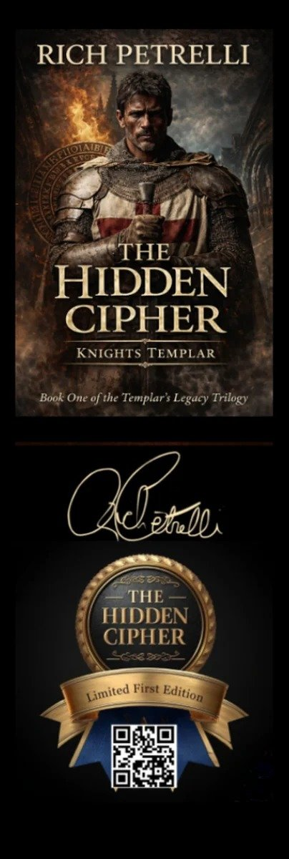
The Hidden Cipher bookmark (Limited First Edition).
DESIGN | The Hidden Cipher (Book 1), Limited First Edition
SIZE | 2" × 6"
AVAILABILITY | Free for bookstores, libraries, book clubs, and events, on request
MINIMUM ORDER | 25
MAXIMUM ORDER | About 100 free per request; for larger quantities, please email first
LEAD TIME | Ships in about 7–10 business days
HOW TO REQUEST | Email press@richpetrelli.com with your name, organization, mailing address, quantity, and event date.

An exclusive bookmark is also included with the Signed Limited Edition Hardcover (1 of 100) of The Hidden Cipher, per thehiddenchalice.com.

12 · CONNECT

Links & Social
AUTHOR WEBSITE | richpetrelli.com
SERIES WEBSITE | thehiddenchalice.com
X (TWITTER) | @AuthorRichP — https://x.com/AuthorRichP
FACEBOOK | Color & Quill Publishing — https://www.facebook.com/colorandquillpublishing
INSTAGRAM | @color_quill — https://www.instagram.com/color_quill/
YOUTUBE | @HiddenCipherBook — https://www.youtube.com/@HiddenCipherBook
GOODREADS | Rich Petrelli — https://www.goodreads.com/author/show/55361481.Rich_Petrelli
AMAZON AUTHOR PAGE | amazon.com/author/richpetrelli — https://www.amazon.com/author/richpetrelli
READER SQUAD (ARC TEAM) | Join the ARC reader group — https://thehiddenchalice.com/join-the-arc-reader-group

Media Contact
MEDIA CONTACT | Rich Petrelli
EMAIL | press@richpetrelli.com
PHONE | (863) 701-4515
CONTACT FORM | richpetrelli.com/contact (choose “Press & Media”)
LOCATION | Florida-based; traveling full-time by RV for more than a decade
REVIEW COPIES | Reviewers can request ARC copies through BookSirens: The Black Chalice — https://booksirens.com/book/ASENY93/TQ0T2V7 (The Hidden Cipher listing coming soon on BookSirens). Media can also email press@richpetrelli.com.

Images & Usage Credits
FILE (ZIP /IMAGES) | DESCRIPTION | SOURCE | CREDIT
author/rich-petrelli-headshot-01.jpg | Author headshot (976×976) | richpetrelli.com | No photo credit required
author/rich-petrelli-headshot-02.jpg | Author headshot, alternate (1024×1024) | thehiddenchalice.com | No photo credit required
covers/the-hidden-cipher-cover.jpg | The Hidden Cipher cover (1800×2700) | thehiddenchalice.com | Cover © Rich Petrelli / Color & Quill. Cover design: Saba (Fiverr)
covers/the-black-chalice-cover.jpg | The Black Chalice cover (1365×2048) | richpetrelli.com | Cover © Rich Petrelli / Color & Quill. Cover design: Saba (Fiverr)
covers/babel-cover.jpg | Babel cover (1365×2048) | richpetrelli.com | Cover © Rich Petrelli / Color & Quill. Cover design: Saba (Fiverr)
characters/*.jpg | Official character portraits (9) | richpetrelli.com/meet-the-characters | No credit required
logos-badges/richpetrelli-site-logo.png | Site logo (1920×1920, transparent) | richpetrelli.com | © Rich Petrelli
logos-badges/readers-favorite-5-star-seal.png | Readers’ Favorite five-star seal (low-res, 144 px) | richpetrelli.com | Readers’ Favorite trademark; use per Readers’ Favorite seal guidelines.
promo/readers-favorite-hidden-cipher-review-graphic.jpg | Readers’ Favorite review quote graphic | thehiddenchalice.com | © Rich Petrelli
bookmarks/the-hidden-cipher-bookmark.jpg | Promotional bookmark — The Hidden Cipher (Book 1), Limited First Edition, 2" × 6" (404×1200) | Rich Petrelli | —
merch/notebook-*.jpg | Templar’s Legacy spiral notebook (comes with free bookmark) — front cover, 2 interior pages, back cover (4) | Rich Petrelli | —

- Images in this kit may be used by media, booksellers, librarians, and event hosts for editorial coverage, reviews, interviews, and event promotion of Rich Petrelli and his books.
- Please do not crop cover art through the title or author name, alter colors, or add overlays. Resizing is fine.
- Credit line for author photos: “Photo courtesy of Rich Petrelli.”
- Credit line for covers: “Cover courtesy of Color & Quill.”
- Commercial or non-editorial use requires permission — contact press@richpetrelli.com.
- Review quotes are excerpts from the cited sources; please keep attribution when reprinting.

Sources
- richpetrelli.com — home, /books, /book/the-hidden-cipher, /book/black-chalice, /book/babel-every-vow-must-be-tested, /meet-the-characters, /press-kit, /contact, /why-i-wrote-the-hidden-cipher (fetched Oct. 20, 2026)
- thehiddenchalice.com — home, /about, /books, /events, /knights-templar-book-release-dates, /cast-and-crew, /order-your-signed-edition-of-the-hidden-cipher
- Readers’ Favorite — readersfavorite.com/book-review/the-hidden-cipher; /book-review/the-black-chalice
- EIN Presswire press release, Dec. 12, 2025 (“Tampa Author Rich Petrelli Earns 5-Star Readers’ Favorite Review…”)
- Goodreads — author page (55361481) and book page (244135364)
- Amazon.com / Amazon.ca / Amazon.it product listings (via search index); Blackwell’s listing for ISBN 9798218942748
- Supplied/approved by Rich Petrelli (Oct. 20, 2026): ISBNs, list prices, page counts and formats; media phone; bookmark details; approved review excerpts (Readers’ Favorite, The Black Chalice; LubyH23 ARC review)

